From: <https://www.davidstockmanscontracorner.com/the-cult-of-the-dow-and-the-senates-night-of-infamy-part-3/>

**The Cult Of The Dow And The Senate’s Night Of Infamy, Part 3**

You could call it the Senate’s Night of Infamy, but even that would hardly do justice to the catastrophe at hand. We are speaking, of course, of the upper body’s 96-0 vote on the 883 page $2 trillion bailout that passed at 11:50 PM last night without a single Senator having read it (some of them being possibly not awake, as well).

Even if Uncle Sam was not already broke with $23 trillion of public debt and $20 trillion more built-in to current policy over the next decade, this bill would rank as a monstrous eruption of fiscal incontinence, as we shall catalogue below.

But what is far worse than its coast-to-coast soup lines and cascade of Free Stuff is the underlying predicates and theories being used to justify it.

In essence, the bill says there is no limit to the amount of money that the state and its central banking branch can borrow or print in order to hold harmless virtually every element and institution of the American economy at their January 2020 level of Fake Prosperity and egregiously inflated financial wealth.

We leave it to the liberal numbskulls at Axios to reveal the true colors of the Everything Bailout. These sanctimonious beltway insiders are statists of the worst variety because rather than overtly embracing socialism like Bernie, AOC and the Squad, they embrace an ersatz version which presumes a hyper-interventionist state is not capitalism’s mortal enemy like classic socialism, but its helpmate, enhancer and benefactor.

But that’s dead wrong. Beltway socialism results in conditions that eviscerate the fundamental pre-conditions for stable, sustainable and rising capitalist prosperity. To wit, beltway socialism:

* systematically falsifies and inflates financial asset prices,
* confers windfall wealth on the already wealthy,
* drastically balloons public and private debt,
* fosters pervasive speculation and malinvestment,
* perpetuates failed business strategies and zombie companies,
* eviscerates financial discipline among households, businesses and government institutions alike,
* kills savings, rainy day funds and balance sheet reserves in favor of hand-to-mouth economics; and
* leaves the aggregate economy unnecessarily fragile and extremely vulnerable to exogenous shocks like the Covid-19 supply side dislocation now underway.

The beltway socialists now applauding the Senate’s perfidy, of course, recognize none of these untoward consequences. By the lights of Axios and the legions of like and similar beltway operatives, the American economy’s apparent inability to weather a 2-4 month supply side dislocation is due to the putative defects of market capitalism, and means that hyperactive state intervention is exactly what the doctor ordered.

As Axios opined this AM, the Senate bill is just a grand act of ***plenary social insurance***designed to make everyone whole (as if the state possessed resources that the society as a whole doesn’t):

*This is not intended to stimulate growth and spending to offset a potential downturn; it is designed to****prevent mass homelessness, starvation and a wave of business closures****not seen since the height of the Great Depression.*

*“This should not be thought of as a stimulus bill — this should be thought of as****social insurance****in a disaster state of the world for the most hard hit,” Jonathan Parker, professor of finance at MIT, told Axios during a virtual briefing with reporters Wednesday.*

* *“The idea is to freeze time for a month or six weeks and let people emerge with****not a huge amount of debt****— not starving, not being evicted.”*
* *This would ideally produce “a V-shaped recovery where people find themselves****roughly where they were when we went in.”***

*Even if the bill passes, the story won’t be over:*

* *We are likely to be in this****same situation****again, economists say — and soon.*
* *Another stimulus bill will likely be necessary to****get the economy running****after the COVID-19 outbreak has been contained.*
* *More immediately, it’s possible that a****second massive spending bill****will be needed just to stop further bleeding.*

Well, there you have it: A bald-faced recipe for the veritable destruction of capitalist prosperity and financial viability. And it’s not merely the opinion of some no count 30-something scribbler at Axios; the author is actually transcribing the consensus extant accross the length and breadth of the beltway.

In that regard, we got the following fund-raising email this AM from the putative Republican Senator, Thom Tillis, from the oh so conservative state of North Carolina.

The man was ecstatic that rich old Uncle Sam was sending money to his constituents “to help you make ends meet”. But don’t call them handouts or socialism:

*As we unite as North Carolinians to fight the coronavirus pandemic, I want to give you an update on legislation to bring relief to Americans…….The bill I supported authorizes a one-time payment in the amount of $1,200 per individual or $2,400 for married couples and $500 per dependent child****to help you make ends meet****as our nation confronts this public health crisis.*

*Workers and small businesses****need help****, which is why this legislation provides supplemental payments for people who become unemployed, and will also help our independent contractors and small business owners****get assistance****to get through this crisis and be able to retain employees on their payroll.*

Needless to say, every one of the bolded phrases in the Axios and Tillis statements above are patent nonsense and indicative of the mindset of the Washington political class and the Wall Street speculator class. These folks no longer even try to perform economic analysis, and, instead, just demand that bigger and bigger government bazookas be randomly fired upon main street and Wall Street alike.

For crying out loud, even if the quasi-shutdown of the US economy lasts for 4 months, it would not lead to a wave of homelessness, starvation and massive business failure in the absence of the Senate spend-a-thon, and here’s why.

First, about half of the US population or ***160 million people***get the overwhelming share of their income from the Welfare State. And the latter, of course, has complete immunity to the Covid-19 because checks just keep coming by statutory entitlement.

This includes***61.3 million***people on Social Security/Medicare, who will receive ***$1.9 trillion***of cash and medicare coverage from the two giant social insurance programs in FY 2020. That computes out to an average of***$62,000***of value per retired couple!

Likewise, in the latest year’s data (2016), fully***114.7 million American’s***(36%) lived in homes receiving means-tested benefits including Food Stamps, Medicaid, public housing, Supplemental Security Income (SSI for blind, elderly and disabled), the Special Supplemental Nutrition Program for Women, Infants and Children (WIN), Temporary Assistance for Needy Families and the National School Lunch Program.

In all, Federal spending on these programs plus unemployment insurance and veterans pensions and disability payments will total **$950 billion** during the current year, and when you add the approximate $350 billion state share of Medicaid, the so-called Safety Net will supply another***$1.3 trillion***of support.

So what you have first of all is a Covid-19 resistant Welfare State that is dispensing***$3.2 trillion***to half the US population without missing a beat. And that massive total has been growing like wild fire over the decades making today’s economic Spring Break essentially a non-event for the recipient population.

Specifically, back in 1960 the Welfare State sent out transfer payments of just **$28 billi*on***, which amounted to ***7.5%***of the ***$376 billion***of disposable personal income (DPI) reported that year. From there, however, it was off to the races after LBJ, Nixon, Carter, Bush the Elder, Clinton, Bush the Younger, Obama and the Donald sequentially loaded up the wagon.

For instance, by the eve of the last crisis in Q4 2007, transfer payments had soared to***$1.8 trillion***or 16.9% of DPI;, and at nearly $32 trillion today,  transfer payments are $1.2 trillion per year higher and stand at ***19.1%***of DPI.

Stated differently, during the last 60 years, Welfare State transfer payments have grown by***114X***compared to DPI less transfer payments of just ***39X.***

Undoubtedly, the self-avowed socialists like Bernie will quibble that $3.2 trillion is not enough.

But what is true is that the most vulnerable half of the US population may as well be on another planet from an income point of view: The overwhelming share of these recipients were not destitute before Covid-19 came along and there has been no change at all in the status quo ante owing to its arrival.

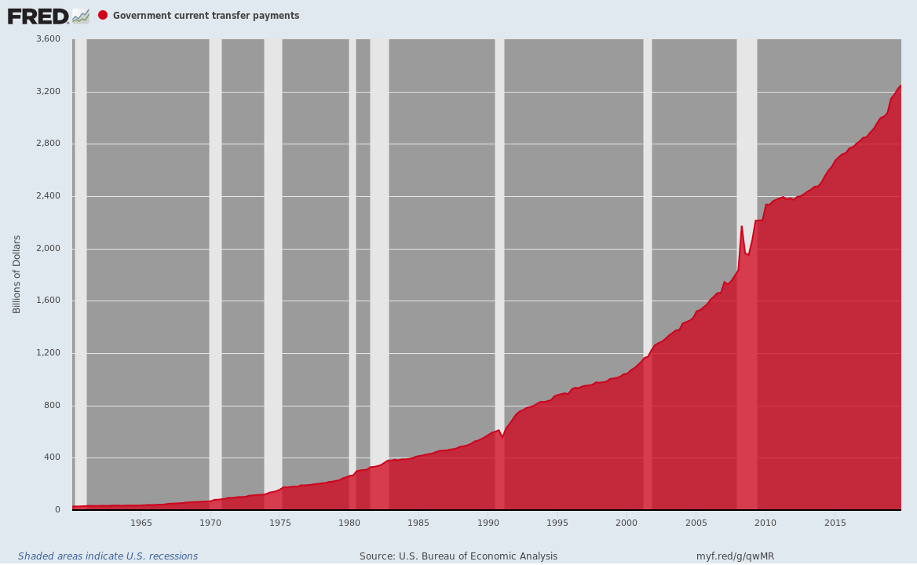

Secondly, for better or worse American social democracy has put in place what amounts to automatic income stabilizers for the working population, a concept that fiscal Keynesians ballyhooed loudly back in the 1960s and 1970s when the Great Depression generation could actually understand what they were talking about.

We are referring to the unemployment insurance system (UI), and the fact that temporarily laid off workers can also access safety net programs like food stamps, free school lunches and Medicaid during periods of wage interruption.

As to the core UI element of the stabilizers, the thin red line on the right margin of the graph below—-which elicited endless gumming on bubble vision today—belies all of the purple rhetoric and crocodile tears gushing through the Senate during last night’s spend-a-thon.

That’s because it shows the heart of the wage shutdown problem had already been taken care of!

That’s right. The 50-state Federal/state UI system processed the astounding total of***3.283 million***new claims last week, and would have done so silently and reliably even had Congress done the right thing and quarantined itself for the duration.

The chart below puts this feat in historical perspective, showing that last week’s new claims were***5X***larger that the ***665,000***processed during the worst week of the Great Recession (March 28 2009). And if need be there is no reason why it will not do so again during the next three or four weeks, which are expected to encompass the peak of the work shutdown phase.

Needless to say, that would result in 10 or even 15 million of continuing claims. In most states the latter are authorized for up to 26 weeks with maximum benefits ranging between $300 and $750 per week.

Moreover, the state intake systems have now proven they can handle weekly payment outflows to the Covid-based unemployed that would range between $5 billion and $8 billion per week at the 10-15 millions claims level.

That is to say, latter figure would represent a***$400 billion annualized run rate***or about 2X the peak UI support level during the Great Recession.

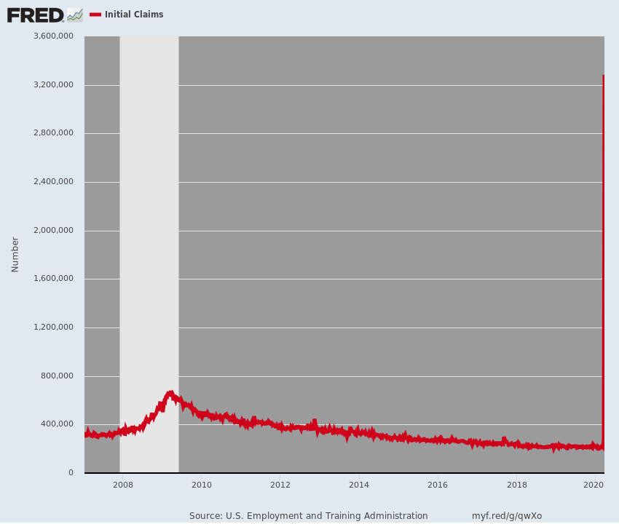

Nor is UI the only part of the built-in income stabilizer that would be kicked into operation. As was evident in the last go-round, when push-comes-to-shove and lower income workers exhaust their resources, the food stamp program can provide a substantial supplement to UI benefits.

Thus, in 2007 the program had 26.3 million beneficiaries and outlays of $30.4 billion per year, largely reflecting the permanent welfare dependent population. By the peak in 2013, however, the rolls had grown to 47.6 million and outlays totaled $76 billion.

Needless to say, a significant share of the ***$46 billion***of annual benefit ***growth***between 2007 and 2013 was comprised of lower income working families, both employed and unemployed, which were able to access the system.

In the current situation, it is unlikely that most of the temporarily quarantined workers will be unemployed long enough, as we will address in Part 4, to access the program.

But it’s there, it has been proven to work, and would have required no midnight madness in the US Senate to effectuate.

Finally, all except the lowest income households, which are already on or eligible for the means-tested safety net have some household savings. As shown below,***median***savings range between $1,400 and $6,000 for families in the $25,000 to $160,000 income range, which are the target of the $300 billion allocated to helicopter checks.

But as to why these families should not be required to draw down their own savings, but instead have Uncle Sam borrow—-so that when the Covid-19 shutdown ends “people find themselves roughly where they were when we went in”—-the beltway socialists do not say; they just presume it since they have the power to make it happen.

But the chart itself shows why helicopter money is a positively awful idea. To wit, can you say Moral Hazard?

As also shown in the chart, the***average***savings level for the $25,000 to $160,000 households is dramatically higher than the ***median***, and ranges from $11,719 to $37,645.

What that means, of course, is that a minority of households are saving a lot, thereby providing for life’s inevitable contingencies and proverbial rainy days, but more than half in virtually every middle income class are saving hardly anything at all.

So now comes the rainy day and future taxpayers by the lights of good Republican “conservatives” like Leader McConnell, Sen. Tillis and the rest have no compunction about taxing the provident in order to indulge the spendthrifts.

**Once upon a time, nearly every Republican in the nation’s capital knew that is exactly the fundamental flaw of socialism.**

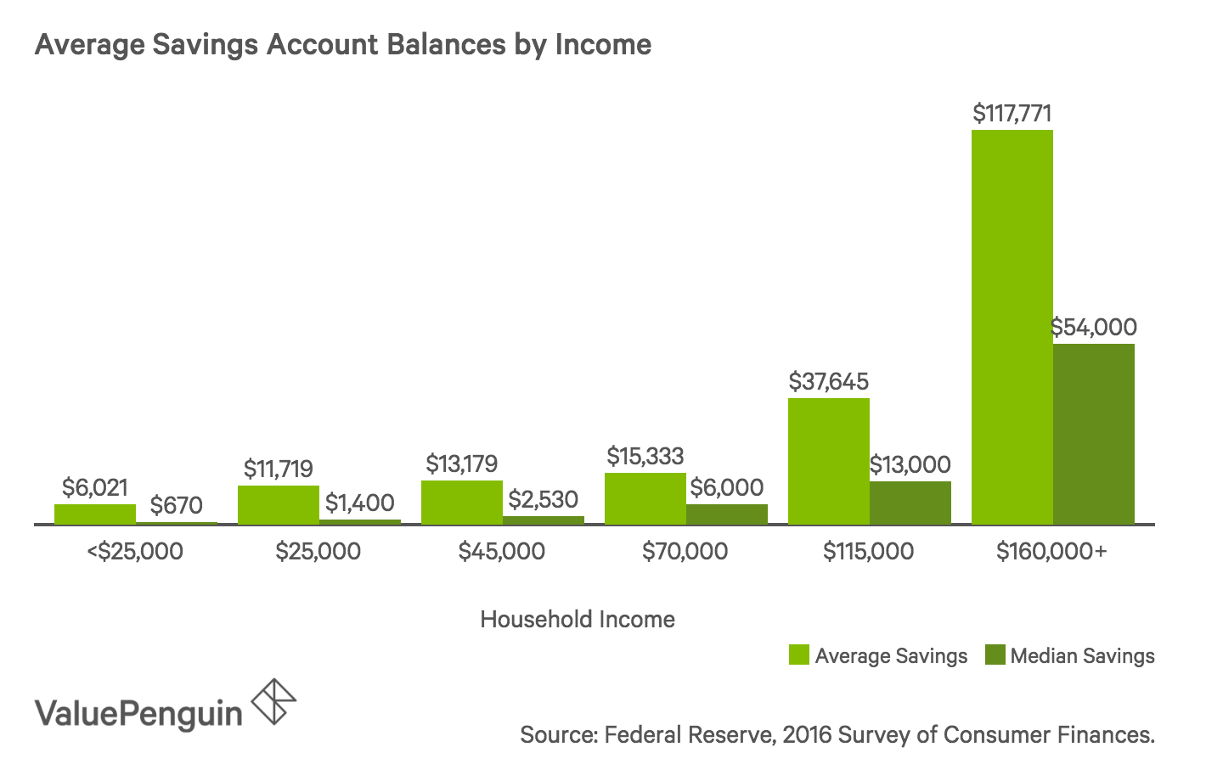

And, of course, it’s also why the US economy is so fragile and can’t seem to weather even a 2-4 month Economic Spring Break.

That is, the era of Keynesian central banking has essentially destroyed the incentive to save, and the data bear out that logical conclusion in spades. But after the GOP sponsored Everything Bailouts, we are hard pressed to imagine how much further the savings function will decline:

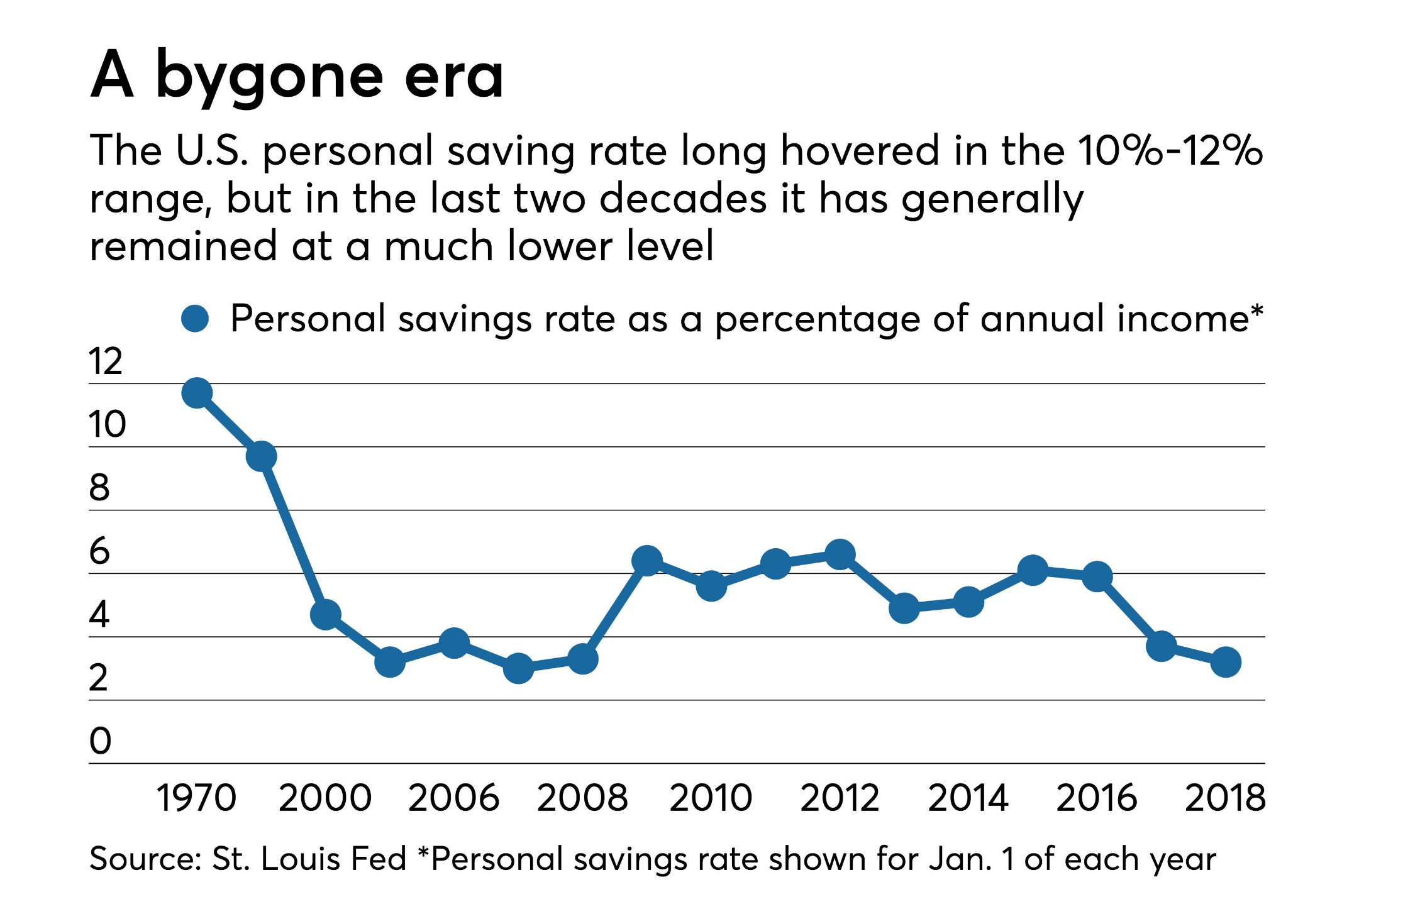

Finally, when the 100% hold-harmless principle gets up as head of steam, as it obviously has in the Senate’s bailout abomination, absolute fiscal lunacy quickly comes to the fore.

One example of how the Everything Bailout amounts to a madcap eruption of Free Stuff designed to replace 100% of GDP is the fact that in February there were  61.3 million social security beneficiaries. But more than 90% of them have incomes under $99,000 and $198,000, which are the helicopter money cutoff points for individuals and married couples, respectively.

So even at the conservative 90% threshold, 55 million beneficiaries will get checks during the second week of April totaling roughly $65 billion.

That’s right. These good Social Security folk have not lost a single dime of income to the Covid-19, but they will get a handout that is nearly as great as the peak annual amount that has ever been spent on foods stamps for the needy (2013).

Sure, most elderly and disabled could use some more income, but then again who couldn’t?

***The issue here, however, is why the Congress is replacing income that hasn’t actually been lost?***

The answer, of course, is that the beltway socialists and keynesian policy-makers falsely believe that the Energizer Bunny must spend, spend, spend to keep the economy going—even if they are just borrowing from future taxpayers and future spending.

As we will amplify in Part 4, that’s patent nonsense. But in the interim it is leading to the most massive spree of central bank monetization in the history of the planet—***$587 billion***just in the last 5 days!

Forgive us, but we are so bold as to believe that this madness most definitely will not end well.

